Model Context Protocol (MCP)

What is MCP and Why Use It?
- MCP = Model Context Protocol: an open standard for providing external context (data, tools) to AI models. It lets AI systems easily connect to databases, APIs, or services in a uniform way.
- The problem it solves: Traditionally, each new data source or tool required custom code and multiple network steps to integrate with an AI model, making systems hard to scale. MCP addresses this by offering one standard “plug” for all integrations.
- “USB-C for AI”: MCP is often described as a universal port for AI, similar to how USB-C works for devices. No matter who builds the AI or the tool, if both support MCP, they can work together seamlessly.
- Benefits: This standardization makes AI applications more reliable and easy to build – less custom glue code, easier context sharing, and faster integration of new capabilities. In short, MCP lets an AI assistant access the info and tools it needs, when it needs them, with minimal fuss.
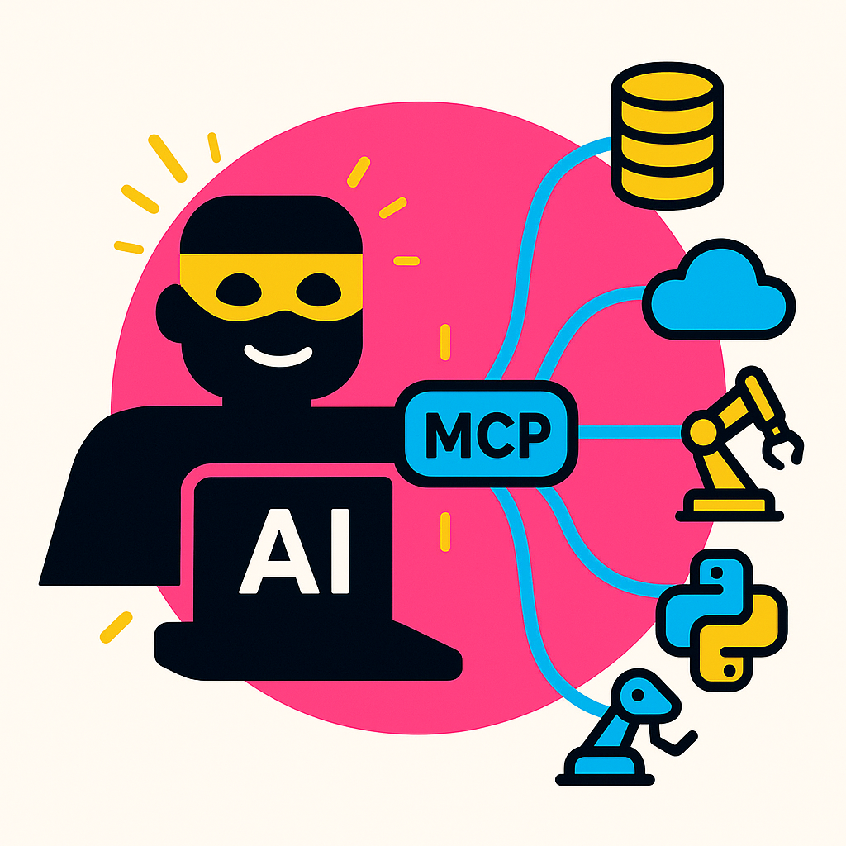

How MCP Works (OpenAI API Context)
- Client–Server model: MCP uses a simple client–server approach. In our case, the OpenAI model (client) connects to an MCP server (tool provider). When the AI needs information or an action, it sends a request to the MCP server, which performs the task (e.g. queries a database, calls an API) and returns the result.
- Direct tool access: By adding an MCP server as a tool in the OpenAI Responses API, the model can interact directly with that server without extra hops through your backend. This reduces complexity and latency – the model itself orchestrates tool use in its “thought process.”
- Integration into API calls: You include MCP servers in the tools array of your API request. When the request starts, OpenAI’s system automatically contacts the MCP server to fetch the list of available actions (“tools”) it provides. This list of tool functions and their descriptions is then added to the model’s context, so the model knows what it can do.
- Tool use during a chat: Once the model knows the available tools, it can decide to invoke one. The Responses API will log the intended tool call (an mcp_tool_call event) and by default pause waiting for your approval (a safety check). If approved (or if you’ve set it to auto-approve), the API executes the tool call via the MCP server and streams the result back into the conversation. The model can then use that result to continue answering the user.
- Multiple transports: (For completeness) MCP supports different connection types for servers – some run locally (via subprocess stdio), others over remote HTTP or Server-Sent Events. The OpenAI system detects and uses the appropriate method automatically when connecting to the server_url you provided.
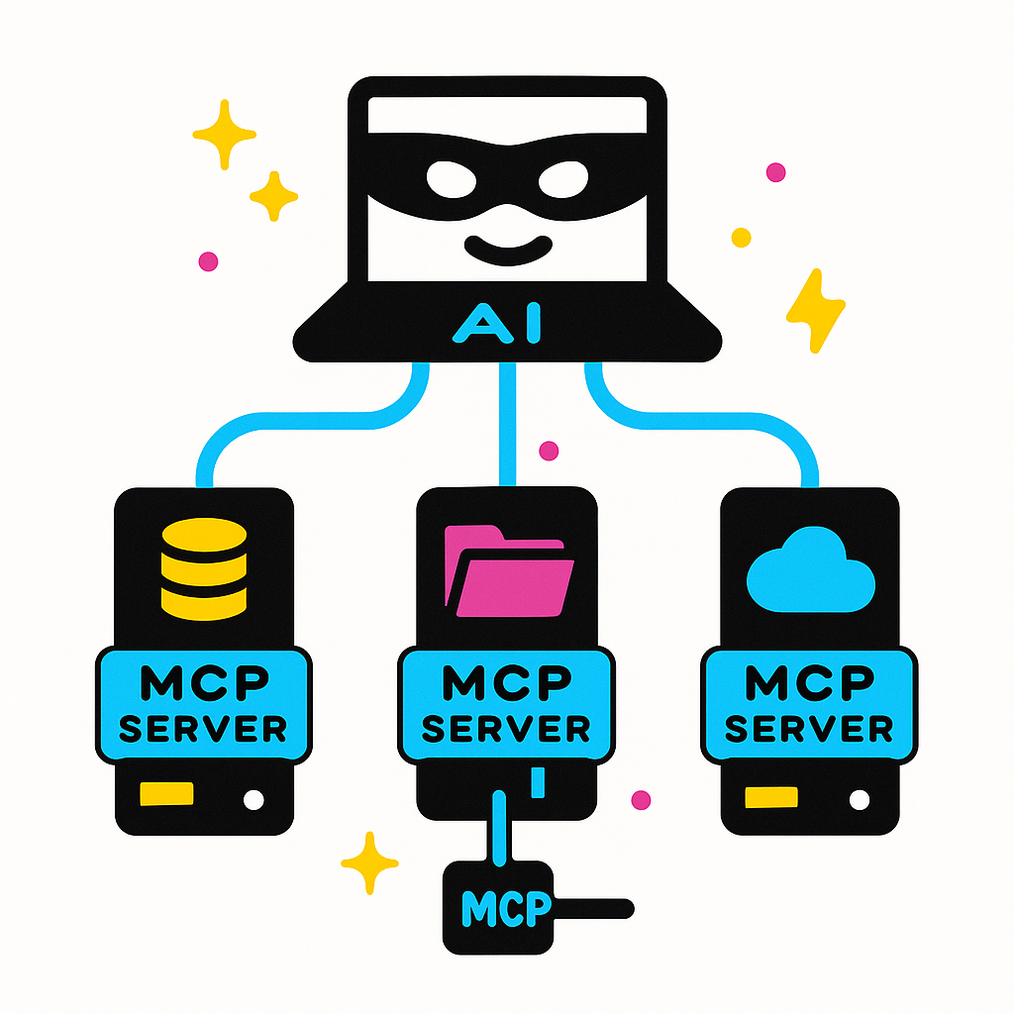

Example – Using MCP in a Request
- Scenario: Imagine a shopping assistant AI that can directly manage a user’s online shopping cart. A user asks: “Add the Blemish Toner Pads to my cart.” We’ll see how a single API call with MCP tools enables the AI to perform this action.
- API Request Setup: We choose a model (say, GPT-4.1) and include an MCP tool pointing to the store’s MCP server. In the JSON payload, model is set to "gpt-4.1", and under tools we add an object for the Shopify MCP server (with a server_label like "shopify" and the store’s server_url). We then provide the user’s request as the input string: "Add the Blemish Toner Pads to my cart". This configuration tells the OpenAI Responses endpoint that our assistant can use the Shopify tool to fulfill the request.
- Behind the scenes: Once the API call is made, the OpenAI system contacts the Shopify MCP server to get the list of actions it supports (for example, it might have an action like add_item_to_cart(product_id) or similar). The model sees those tool definitions and, guided by the instructions and user request, decides to call the appropriate tool (e.g., the “Add to Cart” function on the MCP server). The API executes this tool call through MCP, effectively making the Shopify server add the item to the cart.
- Result: The MCP server returns a result (likely a confirmation and perhaps a checkout URL). The AI model then incorporates that into its final answer to the user. For example, the assistant’s response might be: “The Blemish Toner Pads have been added to your cart! You can proceed to checkout here:” along with a link. All of this happens within a single conversation turn – the user’s request, the tool use, and the assistant’s answer are part of one seamless flow.
# Example request in Python using OpenAI API
response = client.responses.create(
model="gpt-4.1",
tools=[{
"type": "mcp",
"server_label": "shopify",
"server_url": "https://pitchskin.com/api/mcp",
"require_approval": "never" # set to auto-approve tool calls for this example
}],
input="Add the Blemish Toner Pads to my cart"
)

In the code above, we configured the model and provided the MCP tool and input. The response we get will contain the assistant’s message confirming the action.
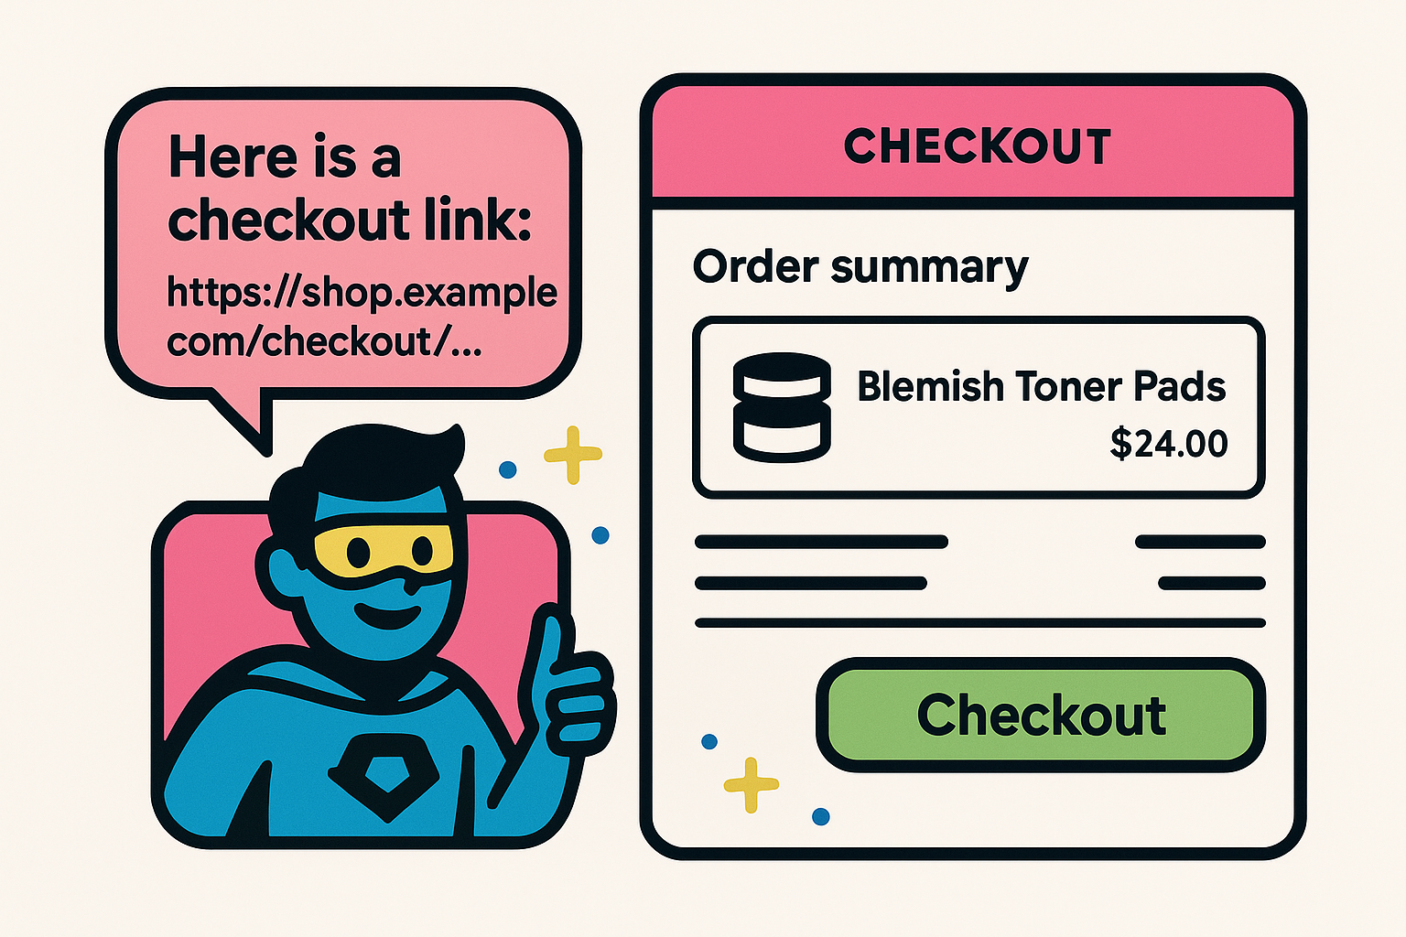

Summary and Key Takeaways
- MCP allows AI models to plug into external tools and data with a standardized protocol – it simplifies what used to require lots of custom integration work.
- With OpenAI’s Responses API, using MCP is straightforward: you declare an MCP server in the tools list and the model can then call that server’s functions as needed, within its chain-of-thought.
- Relevant parameters for using MCP include setting the right instructions (so the model knows it can use tools), choosing a capable model (that supports tool use), providing the conversation messages/input, listing the tools (with the MCP server details), and tuning temperature if desired. Make sure the MCP server is running and accessible to the API (for remote servers, you provide the URL and any auth headers).
- Big picture: MCP is helping bridge AI and the “real world.” Even as a beginner, you can leverage it to have your AI assistant fetch information, use services, or take actions on your behalf – all with minimal code and a consistent approach. This unlocks more powerful and context-aware applications without needing to reinvent the wheel for every new capability. Enjoy building with MCP – your AI’s new universal connector!

